What Canada and Alberta could learn from Norway
Should Canada adopt the same energy model that made Norwegian citizens theoretical millionaires?
Written from an interview with prominent Vancouver business leader Leonard Schein
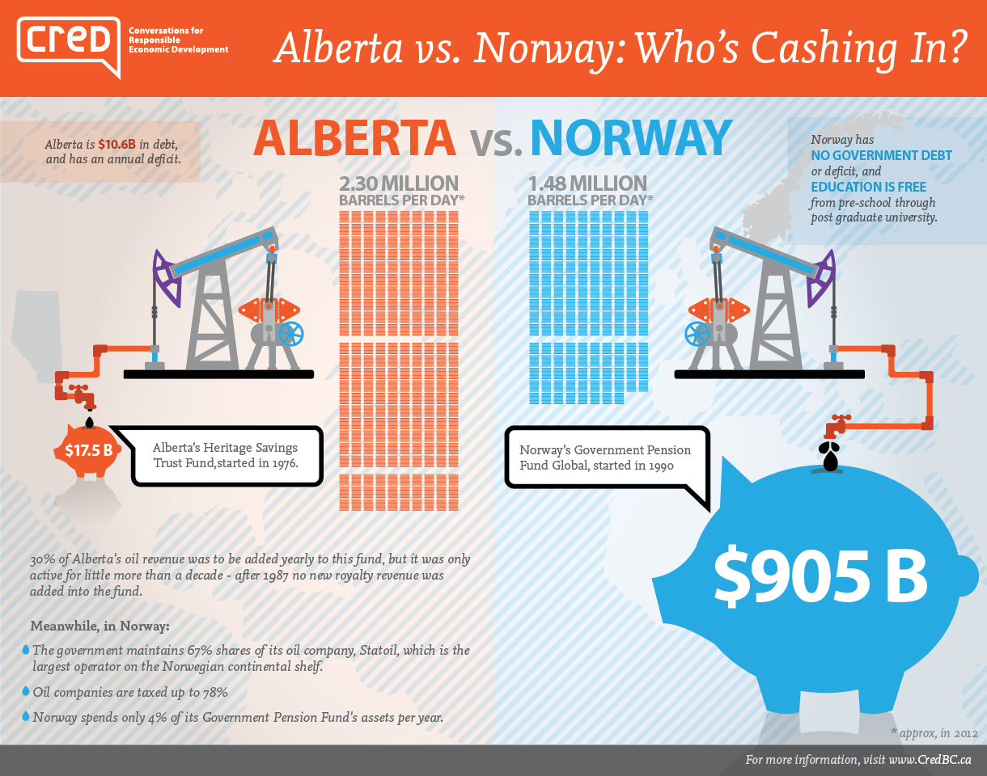
What is Norway’s energy model?
To understand Norway’s energy model, it’s helpful to go back to 1962, when excitement ignited about the possibility of oil in the Norwegian Continental Shelf (NCS). A year later, Norway claimed sovereignty over the NCS and deemed any natural resource found there the property of the government. This initial government response forms the basis of the very different philosophies between Norway and Canada on natural resource ownership. While Norway claims ownership over oil in its land, Canada assumes that any oil in the ground belongs to the companies that extract it.
Playing hardball
The disparate philosophies of the role of government in the oil industry seem to be at the crux of Norway and Canada’s very different paths in the industry. In 1972 the Norwegian government established its own oil company, Statoil, which was awarded 50% of all petroleum production licenses. (Currently the government owns 67% of Statoil, and the other 33% is public ownership.)
At this time the government also put up 50% of the equity for the costs of exploration, but would also keep its equity share of the profits. At first, the oil companies balked at this proposal and took their efforts elsewhere, but the Norwegian government took a ‘take it or leave it’ stance and about a year later the oil companies agreed to Norway’s terms. In contrast, in 2007 an independent Alberta Royalty Review Panel advised that the total government take (Alberta and Canada, taxes and royalties) should be increased, and Alberta could still remain an attractive investment destination. The total take was increased temporarily, but after criticism from the oil and gas industry, royalties were rolled back again in 2010.
Conserving the source
Ever since the first drilling took place, Norway has consciously staggered the extraction of its oil resources. Only a specific number of areas were allowed for drilling at a time, and only a few licenses for extracting were awarded at a time. It seems that Norway rightly predicted that as the world’s population increased, the demand and price for oil would also increase. Early management and long-term planning of the industry is paying off. The average amount of oil per day Norway produced in 2013 was 1.54 million barrels. Canada’s daily production in the same year was 3.36 million barrels a day.

How does Norway have so much money when it has less oil than Canada?
In 1990, the Norwegian government set up a sovereign oil fund, the Government Pension Fund Global, as a place to store the profits from its oil riches and save for future generations. The fund is largely financed by high oil taxes (oil companies are taxed up to a whopping 78% on their profits from Norway oil), and the government only spends 4% of the fund’s assets per year. In January 2014, the fund’s value exceeded 5.11 trillion crowns ($905 billion USD) making it worth a million crowns per person, or about $177,000 USD per Norwegian. By January 2015, it will be worth over one trillion dollars. In addition, Norway has no government debt or deficit, and education is free from pre-school through post graduate university.
Where is Canada’s comparable bounty you ask, which produces twice as much oil as Norway? Alberta is in debt and has a deficit. As of September 1, 2014, the debt has climbed to over $10.6 billion. Schein says that former Alberta premier Peter Lougheed made a positive move when he set up the Heritage Savings Trust Fund in Alberta in 1976 to save and invest some of the oil revenues. 30% of oil royalties were supposed to be added yearly to this fund, but unfortunately it was only active for little more than a decade – after 1987 no new royalty revenue was added into the fund and governments of Alberta have regularly raided the savings trust fund. When Lougheed left office in 1985, it had $16 billion and all these years later, as of June 2014, it has $17.5 billion, a far cry away from the Norway fund that has $905 billion. Alberta is taking from the fund and not adding to it without plans for the future, and it’s a non-renewable resource. What will Alberta do when it no longer has its revenue from a non-renewable resource?
Will this model work in Canada?
The question Schein wants to see discussed is – are Canadians willing to make changes to shift to a model similar to Norway? It would require some big changes, including standing up to pressure from the oil and gas industry. Schein thinks it’s not only possible but important that we begin making these changes immediately. The State of Alaska is now taking a 25% equity position in their LNG resource. They are learning from Norway, why can’t Canada or Alberta learn from Norway, and now Alaska, Schein asks? ”We should be thinking about climate change and planning for the future. We need to look beyond a 4-year election cycle”.
There’s a philosophy here that government cannot be involved in the oil industry, but the vast majority of non-english speaking countries play a very big role in their oil industry.
According to Schein, Alberta and Canada needs to do the following:
  - Alberta should set a 2-3 year deadline of allowing bitumen to be transported out of Alberta. Alberta should then require all bitumen to be refined in the oil sands and they should take an equity position in the refinery. If the bitumen is refined in Alberta, it would mean, for example, that the Northern Gateway and Keystone pipeline would not need to be built. Twin pipelines would not be needed to send back the natural gas condensate so that bitumen can be diluted in order to travel in a pipeline.
  - Revisit the original principles of the Alberta Heritage Savings Trust Fund and follow the Norway example of keeping the income in the fund for when the oil industry no longer generates revenue.
  - Refine oil domestically within the provinces instead of shipping crude products that are then upgraded elsewhere.
  - Create a national energy policy to encourage non-fossil fuels and tax carbon
  - Increase royalty on oil production. On Alberta’s government website, it proudly states Alberta charges oil companies less in royalties than just about any other country in the world (currently around $7/barrel when the price of oil is around $100/barrel). Canada sells oil to the United States for less than we import oil. We should refine our own oil and ship it east. Then we wouldn’t have a need to import more expensive oil.
He argues we would create more jobs, have a better economy now and in the future, and finally deal with climate change and global warming. Canada and Alberta need to learn from Norway’s huge success.
- Which model is the better example of globalisation? Explain.
- In a one half page response argue which model of oil development is the most sustainable?

China: Empire Building in the Age of Globalization
How has China systematically taken advantage of U.S. mistakes and policies?
By Behzad Yaghmaian, April 17, 2013

The United States helped China’s economic ascendance by promoting globalization and embracing, in recent years, a free market orthodoxy. In the annals of history, it will be noted that it was the United States itself that championed a new economic structure which ultimately undermined its own position in the world.
How did this happen? China’s decision to open its economy to the world coincided with the U.S. drive for globalization. U.S. and Western corporations opened the economic floodgates to China through direct investment and subcontracting agreements. As Western capitalism globalized, China became the factory of the world.
Meanwhile, its free market ideology and obsession with balancing the budget became policy straightjackets that hobbled the United States’ ability to spend strategically on its future. As a result, money that could have been spent on education, research and development, modern infrastructure and other requisites for out-competing its rivals was in short supply.
Unencumbered by a free market orthodoxy, the Chinese opted for the opposite choice. They poured resources into areas pivotal for building a robust and competitive economy. China became the unintended winner of the limits of the United States’ free market ideology.
Using its new economic strength, China has been spending its way to the top, displacing the United States in many corners of the world.
China has already surpassed the United States as Africa’s largest trading partner. Since 2005, China has spent more than $56 billion in sub-Saharan Africa, with significant investment in oil, platinum, copper, nickel and manganese and other extractive industries. China’s bilateral trade with African countries rose from $10 billion in 2000 to $125 billion in 2010. It will reach $300 billion by 2015.
China has also been aggressively encroaching into Latin America, once considered a backyard of the United States. China’s trade with Latin America increased by 1,500% between 2000 and 2010. Through loans and foreign direct investment, China is making major inroads into Latin America’s energy and extractive industries. Chinese direct investment in Latin America and the Caribbean reached $15 billion in 2010.
China is currently the largest trading partner of Brazil, Chile and Peru — and the second largest trading partner of Argentina. China has major oil deals with Venezuela, Ecuador and Brazil, and has signed free-trade agreements with Peru, Chile and Costa Rica.
Meanwhile, China has been among the main beneficiaries of the United States’ increasing militarization of conflicts in other strategic regions of the world. The United States spent nearly $940 billion in Afghanistan since 2001.
Afghanistan is estimated to be sitting on $1 trillion worth of underground resources, including copper and lithium. China is a prime candidate for exploiting and developing these resources.
In 2007, Afghanistan awarded China the right to develop the Aynak copper field in the Logar Province, the largest undeveloped copper deposit in the world. In 2011, China signed its first oil deal with Afghanistan.
These projects are just the dress rehearsal for more lucrative opportunities for investment in rebuilding the war-torn country, as well as more resource development contracts after the NATO pullout in 2014. While the United States lost billions of dollars in Afghanistan and faces increasing hostility and resentment from the Afghan people, the Chinese are entering the country with a clean slate.
China is also among the primary winners of Western sanctions against Iran. Sanctions, and barring Iran from the SWIFT banking system and trade in dollars, provided China with an accidental and strategically significant opportunity. As its top trading partner, China is currently purchasing 440,000 barrels of oil per day from Iran, all paid for with yuan.
For many years now, China has been trying to elevate the global standing of the yuan and break the monopoly of the U.S. dollar as the currency of choice in settling international accounts. The recent trade deals with Iran showcased the yuan’s potential as an international currency.
China has also been using the BRICS and other regional alliances to increase its economic and political influence in areas traditionally dominated by the United States. In the past ten years, the Shanghai Cooperation Organization (SCO) has become the primary vehicle to serve China’s growing influence in Central Asia and the wider Middle East.
Iran enjoys an observer status in the SCO. It is only a question of time before it becomes a voting member. Since 2012, Afghanistan has had observer status. Pakistan and India also have observer status and are seeking full membership in the SCO.
Turkey was granted dialogue-partner status in 2012, giving rise to speculation that Turkey might be slowly shifting its sights to SCO membership as a replacement for its thwarted ambition to join the European Union.
Whether in Latin America, Africa or the Middle East, China may have only an incidental interest in helping the peoples and economies of its trading partners. However, through its trade and investment activities, China is achieving what the West has often acquire only by force in the past. Just as globalization has limited the utility of the old methods of empire building, China is emerging with a new model.
1. How has U.S. free market and budgetary policies contributed to China’s economic rise?
2. How is China replacing the U.S on the global stage?
3. China is now a major global economic and political power. Prove this statement using evidence from the article. Your answer should be at least half a page.

